Subject: CN
Class: D12A
Batch: C

Aim: Build a simple network topology and configure it for static routing protocol using GNS3.
Theory:
GNS3 (Graphical Network Simulator) was developed primarily by Jeremy Grossmann.
It is used to emulate, configure, test and troubleshoot virtual and real networks. GNS3 allows us to run a small topology consisting of only a few devices on your laptop, to those that have many devices hosted on multiple servers or even hosted in the cloud (i.e. emulation of complex networks). It basically provides graphical environment.
We may be familiar with VMWare or Virtual PC that are used to emulate various operating systems in a virtual environment. These programs allow you to run operating systems such as Windows XP Professional or Ubuntu Linux in a virtual environment on your computer. GNS3 allows the same type of emulation using Cisco Internetwork Operating Systems. It allows you to run a Cisco IOS (Internetwork Operating System) in a virtual environment on your computer.

GNS3 allows the emulation of Cisco IOSs on your Windows or Linux based computer. Emulation is possible for a long list of router platforms and PIX firewalls. Using an EtherSwitch card in a router, switching platforms may also be emulated to the degree of the card’s supported functionality. This means that GNS3 is an invaluable tool for preparing for Cisco certifications such as CCNA and CCNP.

With GNS3 we are running an actual Cisco IOS, so we will see exactly what the IOS produces and will have access to any command or parameter supported by the IOS.

Also, GNS3 will provide around 1,000 packets per second throughput in a virtual environment. A normal router will provide a hundred to a thousand times greater throughput. GNS3 does not take the place of a real router, but is meant to be a tool for learning and testing in a lab environment.

Advantages:
- Free software
- Open Source software
- No monthly or yearly license fees
- No limitation on number of devices supported (only limitation is your hardware: CPU and memory)
- Supports multiple switching options (ESW16 Etherswitch, IOU/IOL Layer 2 images, VIRL IOSvL2):
- Supports all VIRL images (IOSv, IOSvL2, IOS-XRv, CSR1000v, NX-OSv, ASAv)
- Supports multi vendor environments
- Can be run with or without hypervisors
- Supports both free and paid hypervisors (Virtualbox, VMware workstation, VMware player, ESXi, Fusion)
- Downloadable, free, pre-configured and optimized appliances available to simplify deployment
- Native support for Linux without the need for need for additional virtualization software
- Software from multiple vendors freely available
- Large and active community (800,000+ members)

Disadvantages:
- Cisco images need to be supplied by user (download from Cisco.com, or purchase VIRL license, or copy from physical device).
- Not a self-contained package, but requires a local installation of software (GUI).
- GNS3 can be affected by your PC’s setup and limitations because of local installation (firewall and security settings, company laptop policies etc).

To Install gns3 in Ubuntu:-
- Before installing, add gns3 repo file by using following command.
sudo add-apt-repository ppa:gns3/ppa

- Update the repo by using the following command.
sudo apt-get update

- After the updation is completed, install gns3 as follows.
sudo apt-get install gns3-gui

- Add debian package for i386
sudo dpkg --add-architecture i386
- Update the repo again by using the following command.
sudo apt-get update

- Install gns3 IOS on Unix by using following command.
sudo apt-get install gns3-iou

To Launch the gns3 application
Exit from admin mode: exit
Open the GNS3 application in terminal using “gns3” command: gns3

- To configure the project settings
Select networks and switch images.
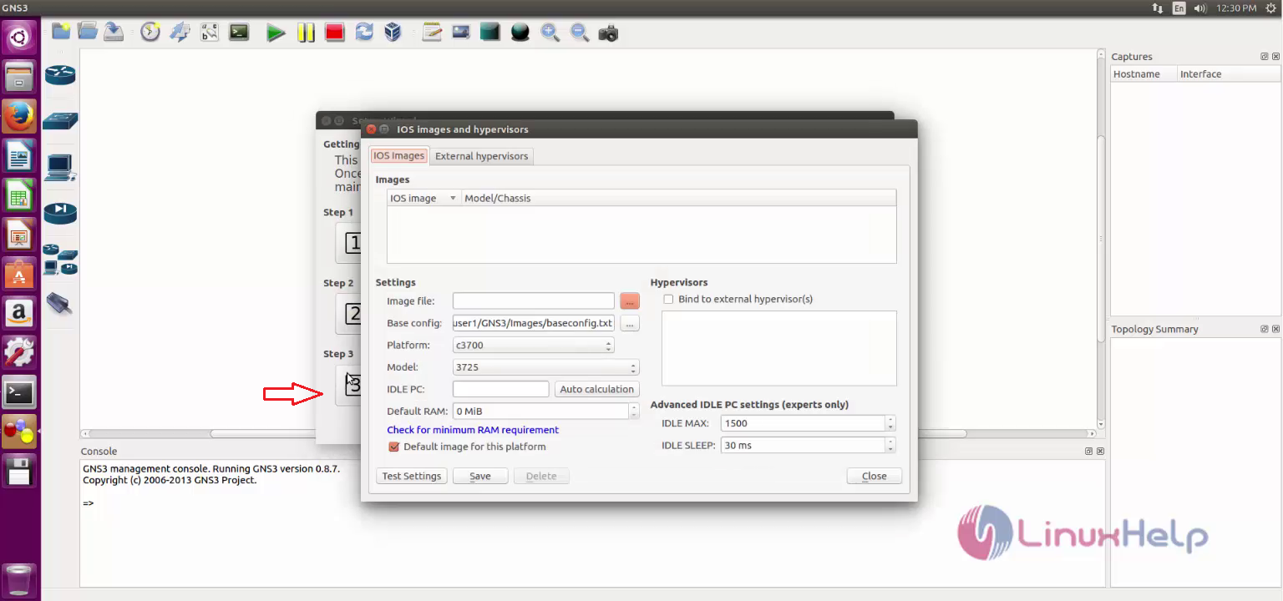
Figure 1: Select image file

- IOS image download link:
https://protechgurus.com/how-to-add-router-ios-image-in-gns3/
- Browse to the router's image on your server's folder.
- When prompted to copy the image in the default directory you can safely answer NO.
- In the field "IOS image path" you must enter the full path of the chosen image.

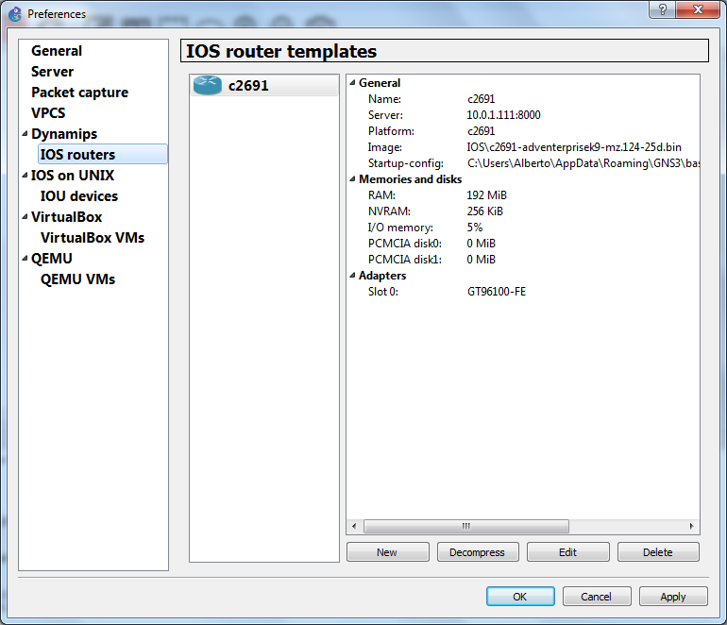
Figure 2: GNS3 preferences

- After that click OK and “close”. Now the gns3 project wizard is ready to use.
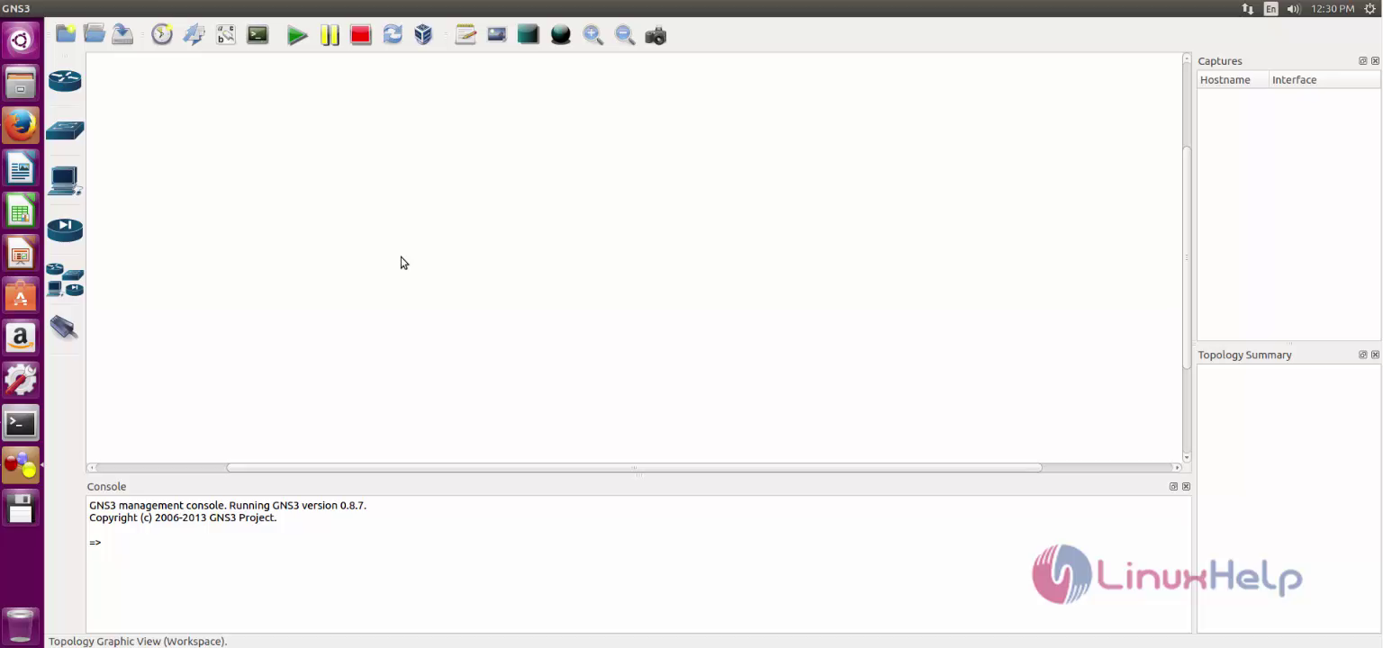
Figure 3: GNS3 project wizard first look

VPCS is virtual PC simulator that is now included in GNS3 devices. We can use it for testing purposes on GNS3, we can ping, traceroute etc with VPCs on GNS3.
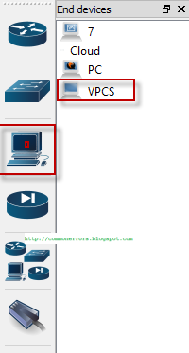
Figure 4: Virtual PC Simulator

Drag the VPCS from end-device on Gns3 dashboard, right click on it and then on start. It will boot in few seconds.

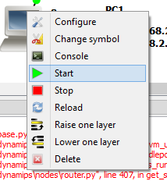
Figure 5: Start using VPCS

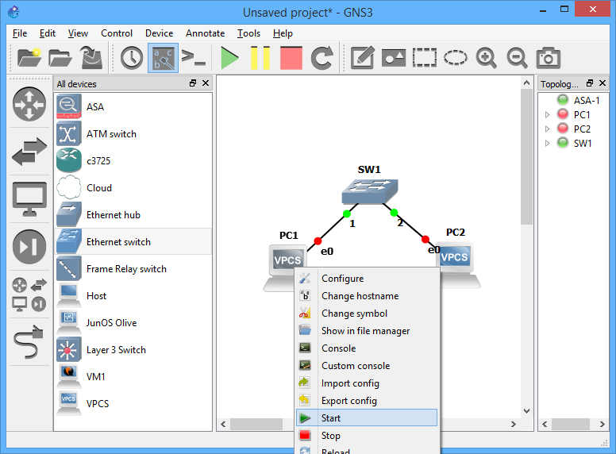
Figure 6: Starting PC1 and PC2 by right click on VPCS icon (Red dot changes to green)

- The sample setup appears as shown below.
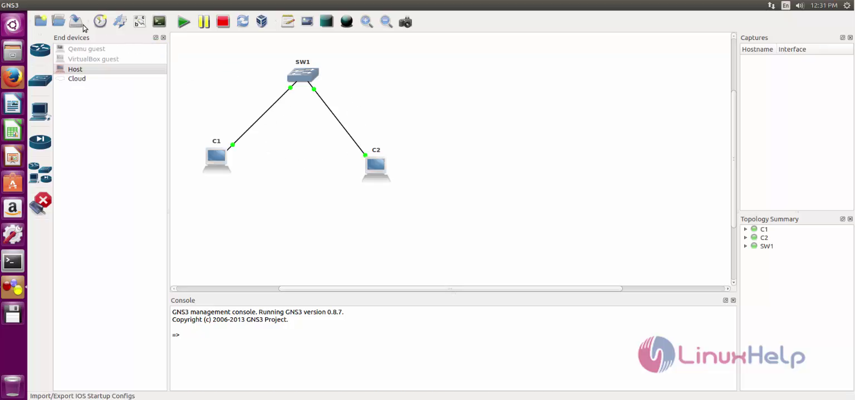
Figure 7: sample setup

- After completing the project click “save project”.
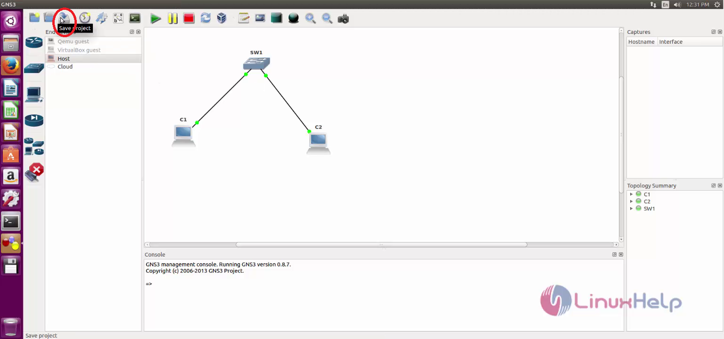
Figure 8: save project

- Enter a project name, path and Click OK.
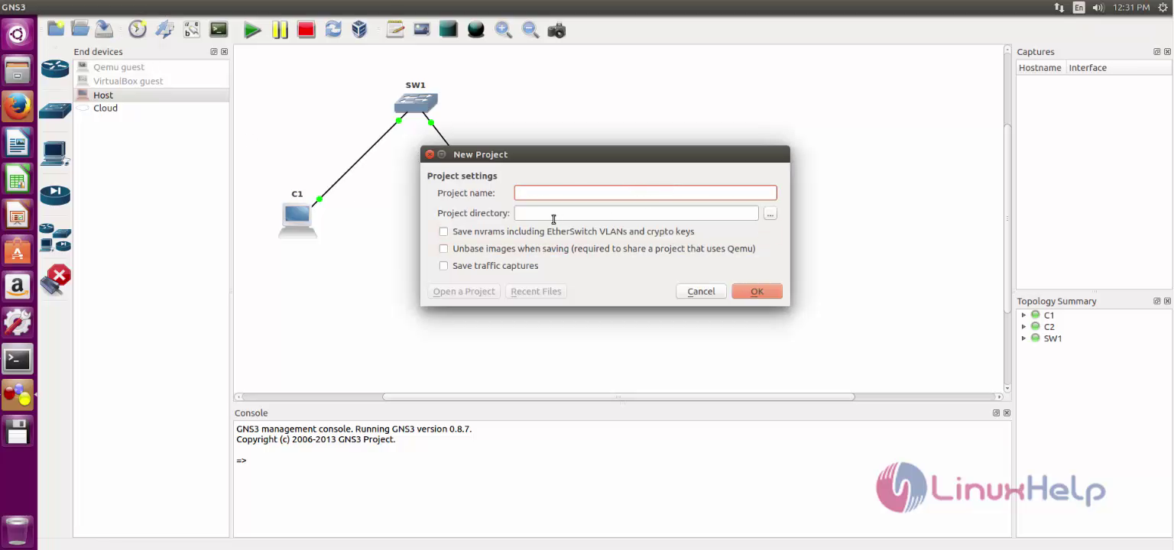
Figure 9: Enter project name and directory

Configure IP addressing
We can use the following command for configuring IP address and gateway for this virtual PC.
IP <address> [/<mask>] [<gateway>]

For example if we want to assign IP address "192.168.2.1" with subnet-mask 255.255.255.0 and gateway "192.168.2.2" we will use the following command:

PC1> ip 192.168.2.1 /24 192.168.2.2

Example: We will configure the TCP/IP settings on VPCS machines as mentioned in the following table.
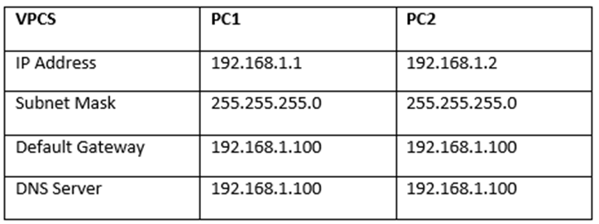

Configure TCP/IP settings on VPCS PC1
- First, execute the following command on PC1 to configure 192.168.1.1/24 IP address and 192.168.1.100 as the default gateway.
PC1>ip 192.168.1.1 /24 192.168.1.100

- Next, execute the following command to configure 192.168.1.100 as DNS server IP address.
PC1>ip dns 192.168.1.100
- Next, execute the following command to view the TCP/IP settings on VPCS PC1.
PC1>show ip
- The figure at end shows the TCP/IP configuration of VPCS PC1.

Configure TCP/IP settings on VPCS PC2
- Execute the following command on PC2 to configure 192.168.1.1/24 IP address and 192.168.1.100 as the default gateway.
PC2>ip 192.168.1.2 /24 192.168.1.100
- Next, execute the following command to configure 192.168.1.100 as DNS server IP address.
PC2>ip dns 192.168.1.100
- Next, execute the following command to view the TCP/IP settings on VPCS PC2.
PC2>show ip
- The following figure shows the TCP/IP configuration of VPCS PC2.
Figure 10: IP configuration of VPCS: PC1 and PC2
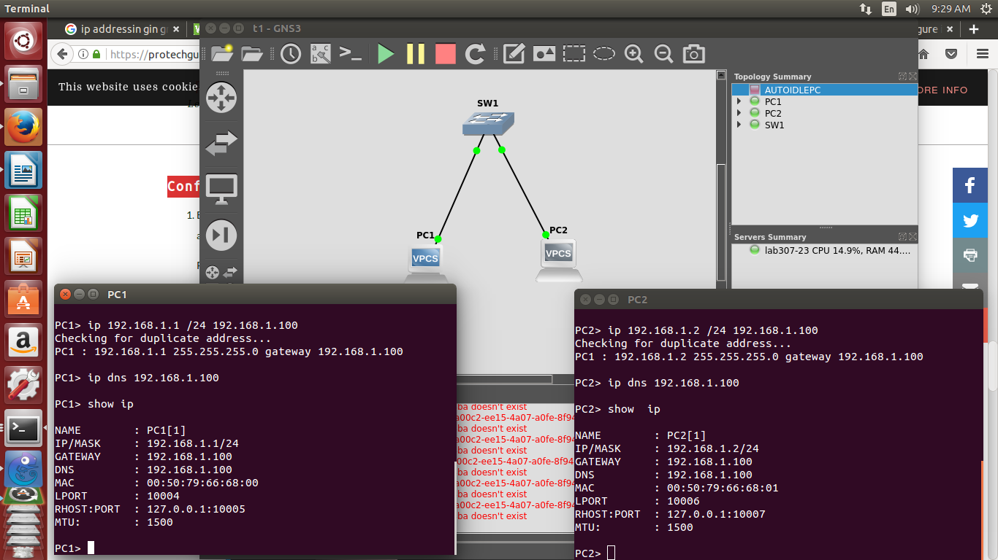
Ping command in gns3: PC1 pings PC2 and vice versa
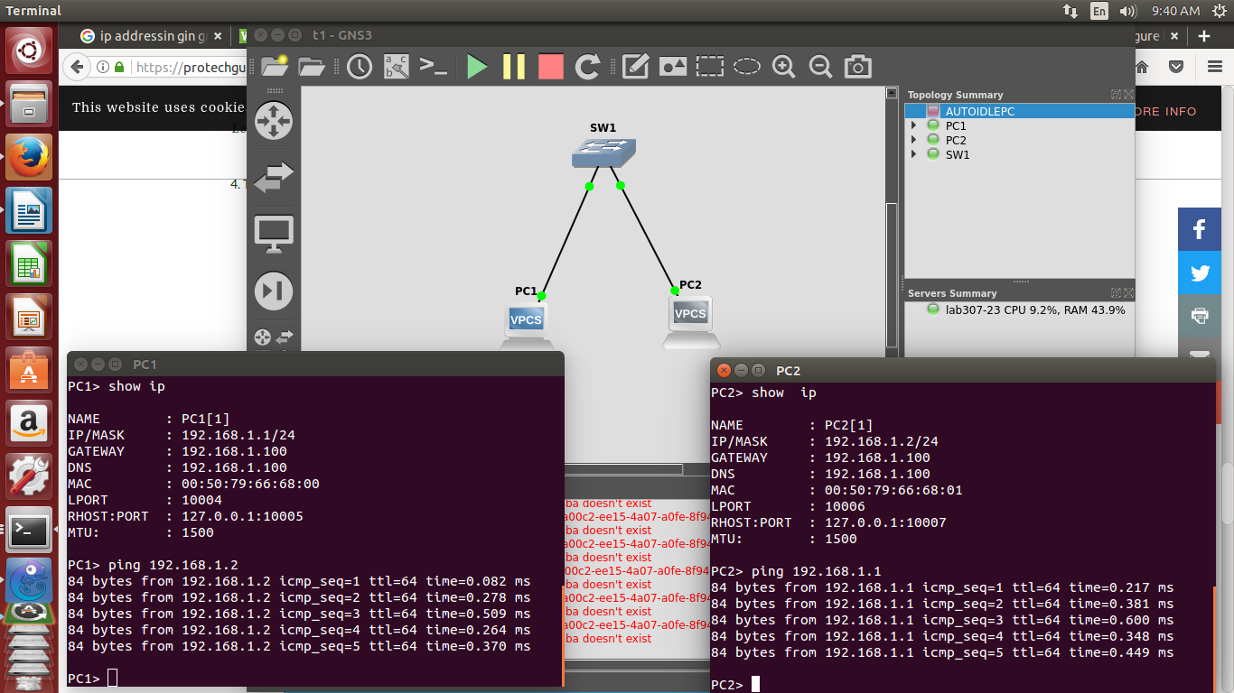
Figure 11: Ping from PC1 to PC2 using GNS3

Static Routing using GNS3
Make a Topology where 1 Router and 2 VPCS are used. These 2 VPCS are connected to the router.

Step I. Configure Router1

a) Configure Port f0/1
R1# configure terminal
R1(config)# interface fastEthernet 0/1
R1(config-if)# ip address 192.168.1.1 255.255.255.0
R1(config-if)# no shutdown
R1(config-if)# exit
R1(config)#
R1(config)#interface fastEthernet 0/0
R1(config-if)# ip address 60.61.62.1 255.255.255.0
R1(config-if)# no shutdown
R1(config-if)# exit
R1(config)#exit
R1#

Step II. Configure PC
[Format:- <IP-subnet mask-gateway>
PC1> show ip
PC1> ip 192.168.1.2 255.255.255.0 192.168.1.1
PC1> show ip

PC2>show ip
PC2> ip 60.61.62.2 255.255.255.0 60.61.62.1
PC2> show ip

Step III. Configure Static router on Router1
R1(Config)# ip route 60.61.62.0 255.255.255.0 f0/0

Step IV. Testing
Ping PC1 to PC2
PC1> ping 60.61.62.0

Ping PC2 to PC1
PC2> ping 192.168.1.2

Note:
To remove ubridge error
sudo chmod 755 /usr/bin/ubridge

To clear ip
clear ip <ip-address>

To clear ip route
clear <routing table entry>

